KWAME NKRUMAH UNIVERSITY OF SCIENCE AND TECHNOLOGY

MECHANICAL ENGINEERING DEPARTMENT

LABORATORY REPORT

HEAT TRANSFER

NAANA TETEBEA OYIRIFI 3756709

GROUP FOUR

13TH April 12, 2012

HEAT TRANSFER EXPERIMENT USING HEAT EXCHANGER

HEAT EXCHANGER

INTRODUCTION
Heat exchangers are devices that allow the exchange of heat between two fluids that are different temperatures without allowing them to mix with each other. Heat exchangers are manufactured in variety of types, the simplest being the double – pipe heat exchanger. Some examples of heat exchanger are intercoolers, preheaters, boilers and condensers in power plants.

Heat transfer in a heat exchanger usually involves convection in each fluid and conduction through the wall separating the two fluids. Radiative transfer between the exchanger and the environment can usually be neglected unless the exchanger is uninsulated and its external surfaces are very hot. In the analysis of heat exchangers, it is convenient to work with an overall heat transfer coefficient U that accounts for the contribution of all these effects on heat transfer. In the analysis of heat exchangers, it is usually convenient to work with the logarithmic mean temperature difference LMTD which is an equivalent mean temperature difference between the two fluids for the entire heat exchanger.

TYPES OF HEAT EXCHANGERS
Different innovative heat exchanger designs have emerged in an attempt to match heat transfer hardware to the heat transfer requirements. There are several types of heat exchanger:
- recuperative type, in which fluids exchange heat on either side of a dividing wall
- regenerative type, in which hot and cold fluids occupy the same space containing a matrix of material that works alternatively as a sink or source for heat flow
- Evaporative type, such as cooling tower in which a liquid is cooled evaporatively in the same space as coolant.
The recuperative type of heat exchanger which is the most common in practice may be designed according to one of the following types:
- Parallel-flow
- Counter-flow
- Cross-flow

Three conditions exist:

Heat transfer at the inner surface:

Q = 2πR₁h₁ (T_{A} – T₁)

Conduction through the wall:

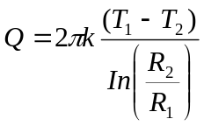
Heat transfer at the outer surface:
Q = 2πR₂h₂ (T₂ – T_{B})
Hence:
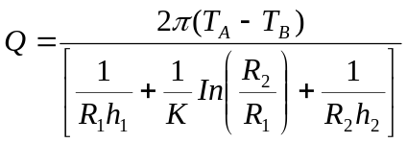

The bottom part of the above equation is termed the overall heat transfer factor, h_{o}, and is written as:

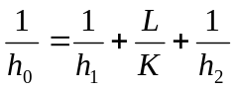

where L is the length of the conduction path and k is the thermal conductivity of the conduction material in our case the pipe wall. For a tubular heat exchanger if the overall heat transfer factor is referred to the inner surface area we have:

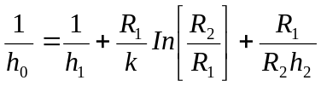
and if the overall heat transfer factor is referred to the outer surface area we have:
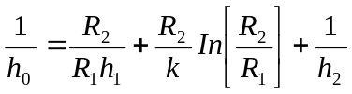

Fouling factor

In addition to the individual heat transfer resistances mentioned above there may be an additional resistance associated with the formation of film of dirt
or scale deposit on the surface of the tube. This is usually allowed for by including a ‘foul factor’ when calculating the overall heat transfer. Fouling is of major importance in industrial process plant where fouling impairs the efficiency of the plant, reducing product yields and thus leading to significantly greater costs.
So instead of the equation on the previous page for overall heat transfer factor we have:
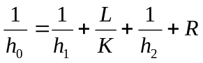

R is sometimes written as 1/f to be in keeping with the equation.,

The total heat transfer rate for a heat exchanger of surface area A is given by:

q = AU_{m} T_{lm}
The above expression is formulated using Logarithmic Mean Temperature Difference (LMTD) Method
U_{m} is the mean overall coefficient of heat transfer
(10)
and is the logarithmic mean temperature difference (LMTD), given by
(11)
Further specification of then "sizes" the heat exchanger, i.e., determines A and the dimensions of the internal flow passages.

Counter-flow Heat Exchanger
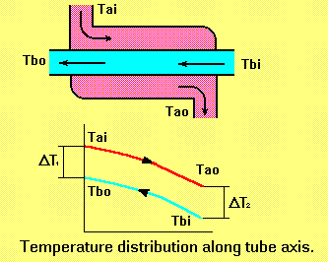
Parallel-flow Heat Exchanger
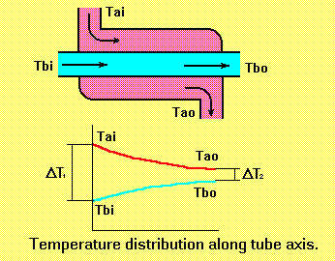

Heat Transfer Analysis With Dimensionless Numbers

A series of dimensionless numbers are used to aid heat transfer calculations. They are based on various physical parameters of the case in question. As the parameters are always used in general equation they enable a series of configurations to be examined rapidly for a given heat transfer situation.

Nusselt Number Nu 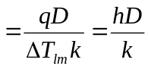

Peclet Number Pe = C_{p} ρUm D
k

Reynolds Number Re = ρUm D
μ

Prandtl Number P_{r} = μC_{p}
K

Stanton Number = h
ρU_{m}C_{p}

The Nusselt number is a dimensionless heat transfer coefficient which gives a measure of ratio of the heat transfer rate q to the rate at which heat would be conducted within the fluid under a temperature gradient Δθ/D.

The Stanton number is an alternative heat transfer coefficient and gives a measure of the heat transfer factor h to the flow of heat along the pipe per unit temperature rise, due to the heat capacity of the fluid.

The Prandtl number is the ratio of kinematic viscosity to thermal diffusivity.

Note that St = Nu
R_{e} P_{r}

It has been experimentally established that for turbulent flow in a long tube and where the Prandtl number of a fluid is greater than 0.5, heat transfer rates can be calculated to within +/-10% from:

Nu = 0.023 Re^{0.8} Pr ^{0.4}

OBJECT OF THE EXPERIMENT

The object of the experiments is to evaluate various non dimensional numbers and thus characterize the heat exchanger for air to water heat transfer.

THE APPARATUS

The apparatus is illustrated upon page three of this manual. It consists of two double pipe units which are fitted with thermocouples. One unit has a “fouling coating” on the outside of the inner pipe. Hot air is supplied from a blower gun unit, covered by its own booklet. Both pipe units are connected to a cooling water supply which is fitted with the flow meter on the inlet. The flow meter has a digital display reading in letters/minutes. A valve square is used to select parallel or counter flow and each pipe unit has a shut-off valve.
Thermocouples are fitted to the various parts of the exchanger and linked to a selector unit with a digital readout.
Location Clean tube Fouled tube
Water, left-hand end 1 7
Air inlet 2 8
Pipe surface left-hand 3 9
Pipe surface right-hand 4 10
Air outlet 5 11
Water, right-hand end 6 12

METHOD

Select a tube to test, the clean one is at the rear and the front tube has the fouling coating. DO NOT exceed a wall temperature of 80°c or the fouling coating, thermocouples and adhesive bonding may be damaged.
Set the cooling water flowing. Then start the hot air blower. Monitor the thermocouples at the tube inlet, both air and pipe surface 2, 3 or 8, 9 as appropriate. Allow conditions to stabilize.
Then for a range of water flow-rates note the flow-rates and the thermocouple readings. Allow sufficient time for readings to stabilize after each adjustment of water flow.
Try parallel and counter flow and compare your temperatures with the profiles on pages 12 &13. then evaluate the various non-dimensional numbers outlined in the theory section and the following pages.

CLEAN TUBE – PARALLEL FLOW

LEVEL OF WATER IN TANK | FLOW RATE  TIME/ s | TEMPERATURE ºC
LEVEL OF WATER IN TANK | FLOW RATE  TIME/ s | 1 | 2 | 3 |  | 4 | 5 | 6
5/5 | 3.60 | 27 | 132 |  | 27 | 27 | 43 |  | 27
4/5 | 7.20 | 27 | 128.5 |  | 27 | 27 | 43 |  | 27
3/5 | 7.04 | 27 | 130.5 |  | 27 | 27 | 43 |  | 27
2/5 | 7.24 | 27 | 130 |  | 27 | 27 | 43 |  | 27
1/5 | 8.76 | 27 | 129 |  | 27 | 27 | 43 |  | 27

CLEAN TUBE – COUNTER FLOW

LEVEL OF WATER IN TANK | FLOW RATE TIME/ s | TEMPERATURE ºC
LEVEL OF WATER IN TANK | FLOW RATE TIME/ s | 1 | 2 | 3 |  | 4 | 5 | 6
5/5 | 6.88 | 27 | 137 |  | 28 | 27 | 44 |  | 26
4/5 | 6.82 | 27 | 144 |  | 28 | 27 | 44 |  | 26
3/5 | 6.92 | 27 | 140 |  | 28 | 27 | 44 |  | 27
2/5 | 7.28 | 27 | 141 |  | 28 | 27 | 44 |  | 27
1/5 | 8.08 | 27 | 141 |  | 28 | 27 | 44 |  | 27

FOULED TUBE – PARALLEL FLOW

LEVEL OF WATER IN TANK | FLOW RATE TIME/ s | TEMPERATURE ºC
LEVEL OF WATER IN TANK | FLOW RATE TIME/ s | 7 | 8 | 9 |  | 10 | 11 | 12
5/5 | 6.55 | 26 | 109.5 |  | 27 | 27 | 38 |  | 27
4/5 | 7.24 | 27 | 103 |  | 27 | 27 | 38 |  | 27
3/5 | 7.47 | 26 | 104.5 |  | 27 | 27 | 38 |  | 27
2/5 | 7.26 | 26 | 108 |  | 27 | 27 | 38 |  | 27
1/5 | 7.79 | 27 | 107 |  | 27 | 27 | 38 |  | 27

FOULED TUBE – COUNTER FLOW

LEVEL OF WATER IN TANK | FLOW RATE TIME/ s | TEMPERATURE ºC
LEVEL OF WATER IN TANK | FLOW RATE TIME/ s | 7 | 8 | 9 |  | 10 | 11 | 12
5/5 | 8.00 | 27 | 107.5 |  | 27 | 27 | 38 |  | 26
4/5 | 7.60 | 27 | 106.5 |  | 27 | 27 | 38 |  | 27
3/5 | 7.63 | 27 | 108 |  | 27 | 27 | 38 |  | 26
2/5 | 7.39 | 27 | 107 |  | 27 | 27 | 38 |  | 26
1/5 | 7.91 | 27 | 108.5 |  | 27 | 27 | 38 |  | 26

RESULTS

Parallel and counter flow for both clean and fouled tube

T_{a1}= temperature of hot air at inlet
T_{a2} = temperature of hot air at outlet
T_{L1}= temperature of water
T_{L2} = temperature of water at right hand end

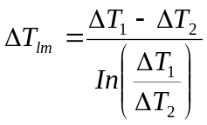

For parallel flow For counter flow
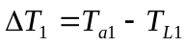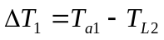
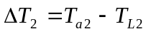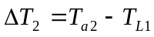

Volume of flask to fill (V) = 1 ml=10⁻³ m³

Flow rate Q 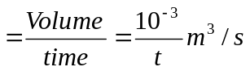

Water velocity in the annulus is given by:
Water velocity u_{m} 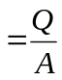
The flow rate is given by the meter and should be converted into litres per seconds.(divide by 60). A is the area of the annular passage.

D₁ = outside diameter of the inner tube = 22.0mm = 0.022m
D₂ = inside diameter of the outer tube = 26.3mm =0.0263m

D_{E} = D₂ - D₁ = 0.0263 – 0.022 = 0.0043m

D_{E} – the equivalent diameter for the annular passage.

Area 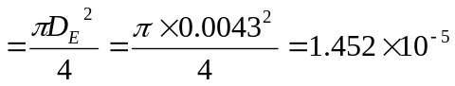

The various properties of water are evaluated at the average values of the flow rate Q and ∆T_{lm} as shown in the table below:

Tube  Flow type | Temp  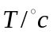  average | Water rate  Q=L/s  average | Flow velocity  U_{m} (m/s)  u_{m} | Density ρ  (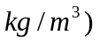 | Specific  heat c_{p}  (J/kgK) | Thermal Conductivity k | Dynamic  viscosity  υ (m²/s)  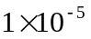 | Prandtl  Number Pr
Clean tube  Parallel flow  Counter flow  Fouled tube  Parallel flow  Counter flow | 46.73  50.97  34.77  35.15 | 0.1622  0.1396  0.1382  0.1298 | 11.163  9.61  9.51  8.93 | 991.50  989.55  996.27  996.15 | 4180.02  4181.29  4179.05  4178.97 | 0.6357  0.6406  0.62  0.6205 | 0.0597  0.6406  0.075  0.0743 | 3.897  3.616  5.04  4.991

Nusselt Number, Nu

Peclet Number, Pe = C_{p} ρUm D
k

Reynolds Number, Re = ρUm D
μ

Prandtl Number, Pr = μC_{p}
K

Stanton Number, St = h
ρU_{m}C_{p}

Clean tube analysis

Parallel flow

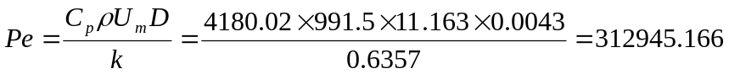

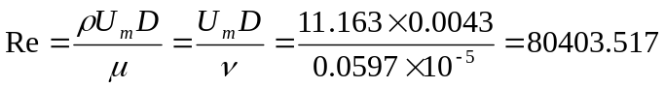

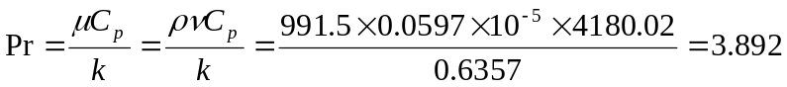
Nu = 0.023 Re^{0.8} Pr ^{0.4} =

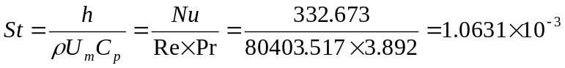
Nu

Counter flow

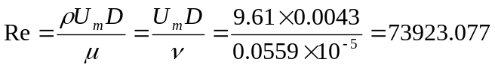

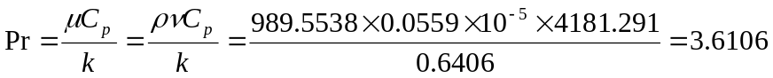
Nu = 0.023 Re^{0.8} Pr ^{0.4} =

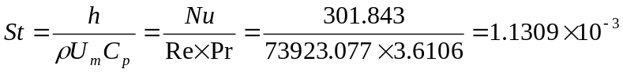
Nu

Fouled tube analysis

Parallel flow

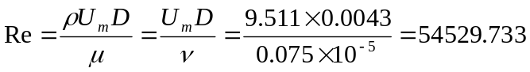

Nu = 0.023 Re^{0.8} Pr ^{0.4} =

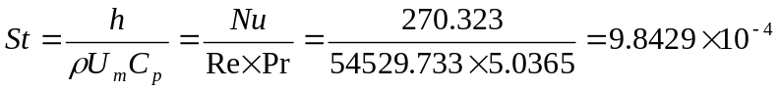
Nu

Counter flow

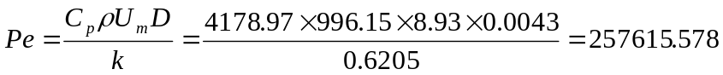

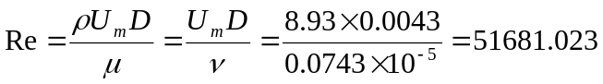

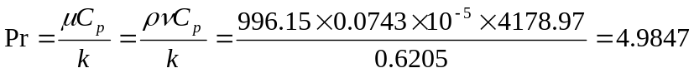
Nu = 0.023 Re^{0.8} Pr ^{0.4} =

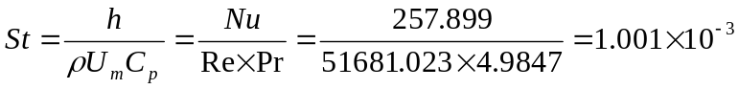
Nu

CONCLUSION

In many problems in which conduction, convection and radiation occur simultaneously; such problems can be treated simultaneously with the aid of an overall heat transfer coefficient. Under certain conditions there is a significant interactions between the different modes, however it is difficult to allow for such interactions and is normally neglected in practical calculation.

REFERENCES
- Dr Forson lecture handout
- Lab book given out by the technician

